**CHAPTER 1**

**Hotel Room Booking Management System**

**Description of the study**

Hotel booking has become an important part of modern society, hence the need for a system that can easily be managed by the hotel owners without having to put in a lot of effort. Room management will become more effective as a result, as the system will offer features like pricing and reservation management that will aid to maximize occupancy possibilities and revenue growth. This system makes it easier for guests to make reservations as it lets them do it via online with a real time availability and pricing information.

Furthermore, in this study, this proposal focuses on the Room Booking Management System for the hotel owners to manage their room hotel services. Thus, the Room Booking Management System is one of the tools that can automate the process and reduce management time as the system will optimize the booking process, lighten the administrative workload and improves the booking experience for both the hotel owners and the guests.

Overall, the hotel booking management system simplifies and automates the reservation process, ensures precise room inventory control, and offers insightful data for wise decision-making. Additionally, it improves the efficiency of the hotel business and the experience of the customers.

**Business Rules**

* A guest can occupy one room.
* A room can be booked to only one guest.
* A guest have one and only one reservation
* A guest can pay using various payment method
* Each reservation is associated with a unique ID
* An employee can view details of all booked rooms
* A payment must have one reservation.
* A room can have as many reservations.

**CHAPTER 2**

**Entity Relationship Diagram (ERD)**

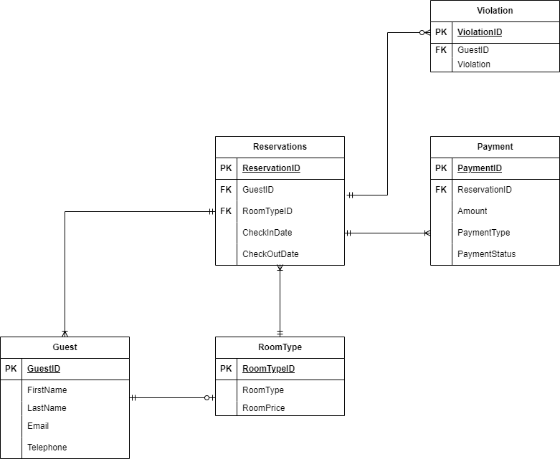

**Logical Design**

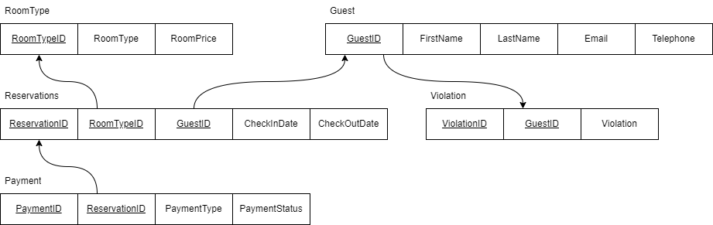

**Normalization**

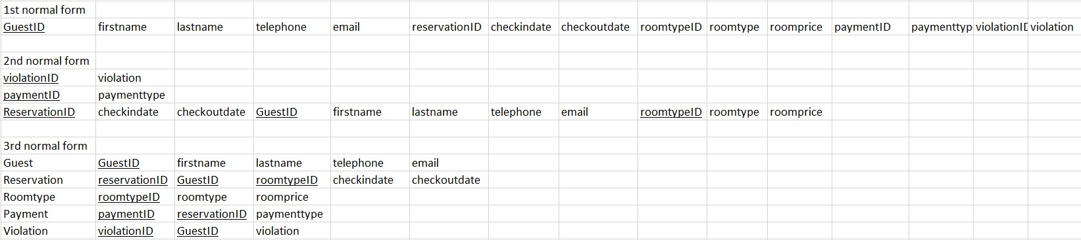

**CHAPTER 3**

**Physical Design**

1. **Create Table**
2. **Guests**

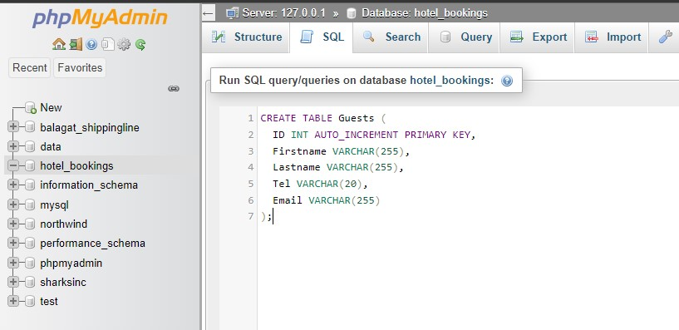

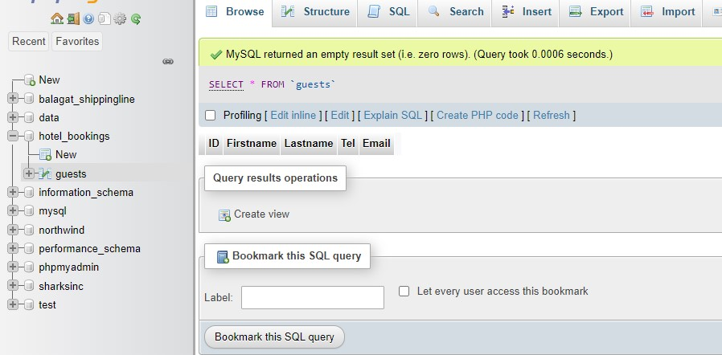

1. **Payments**

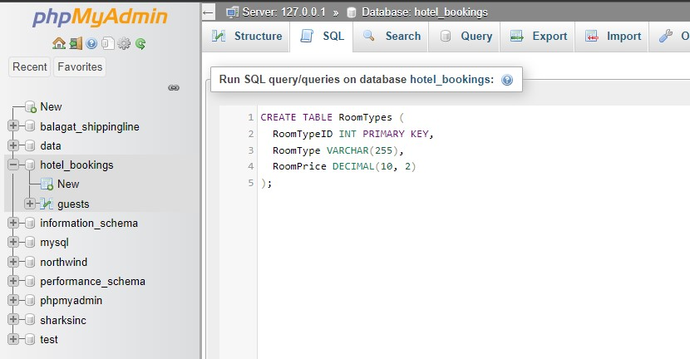

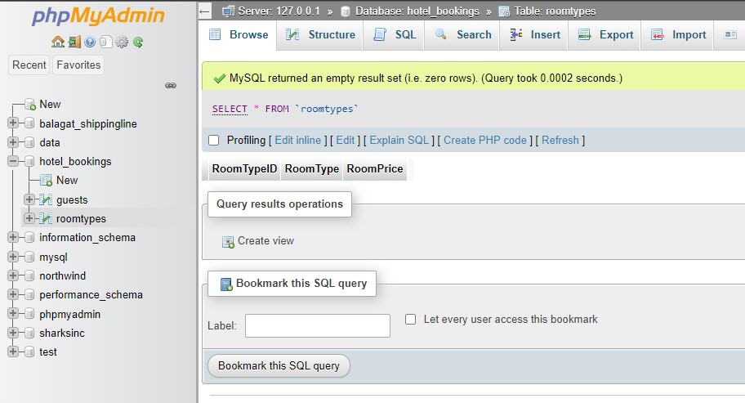

1. **Reservation**

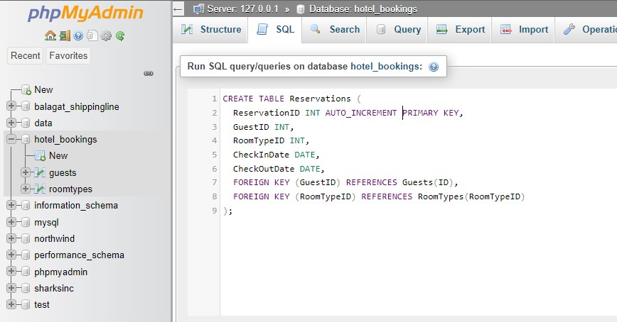

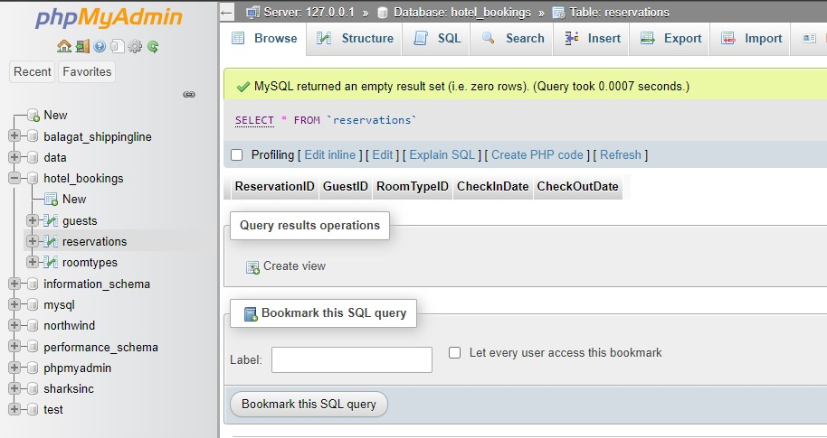

1. **Room types**

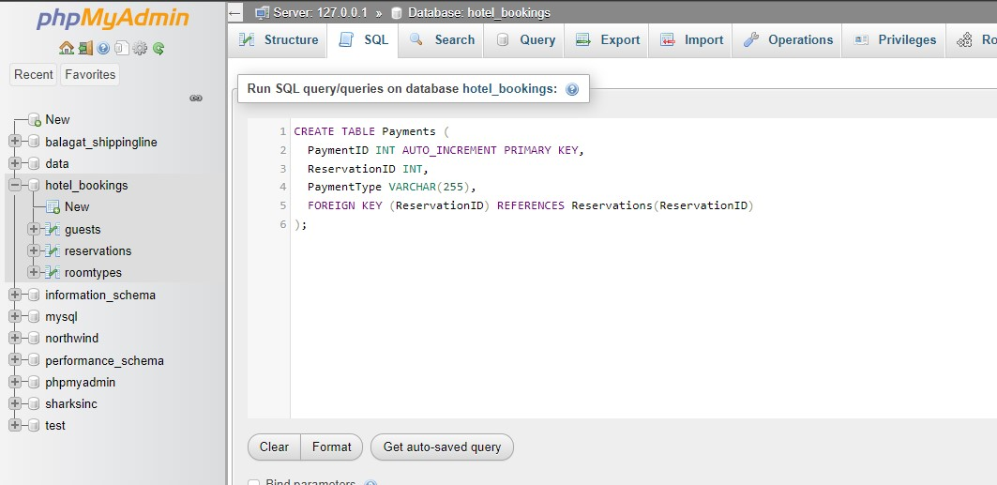

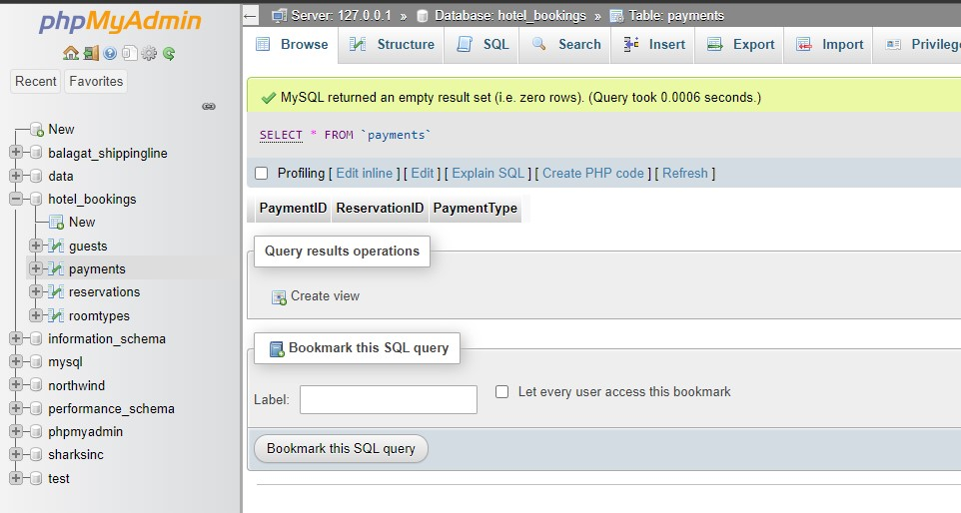

1. **Violations**

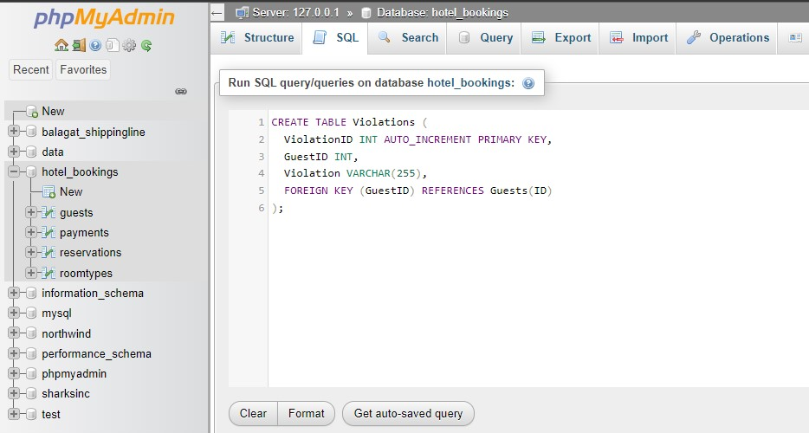

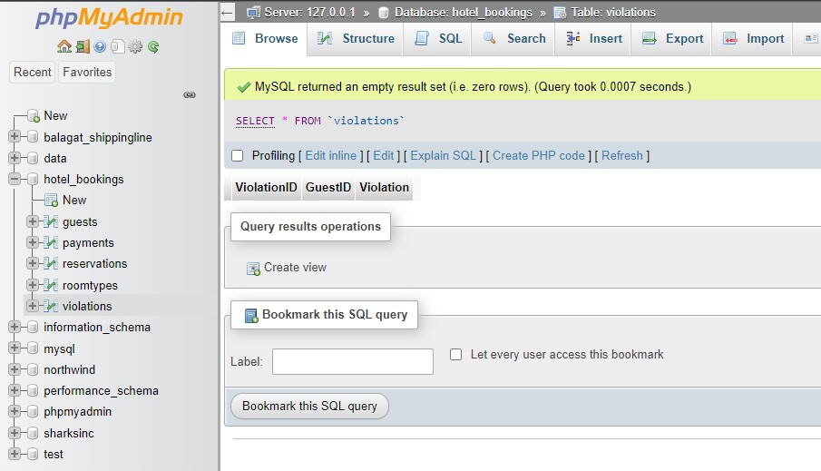

**2. Insert table**

1. **Guest**

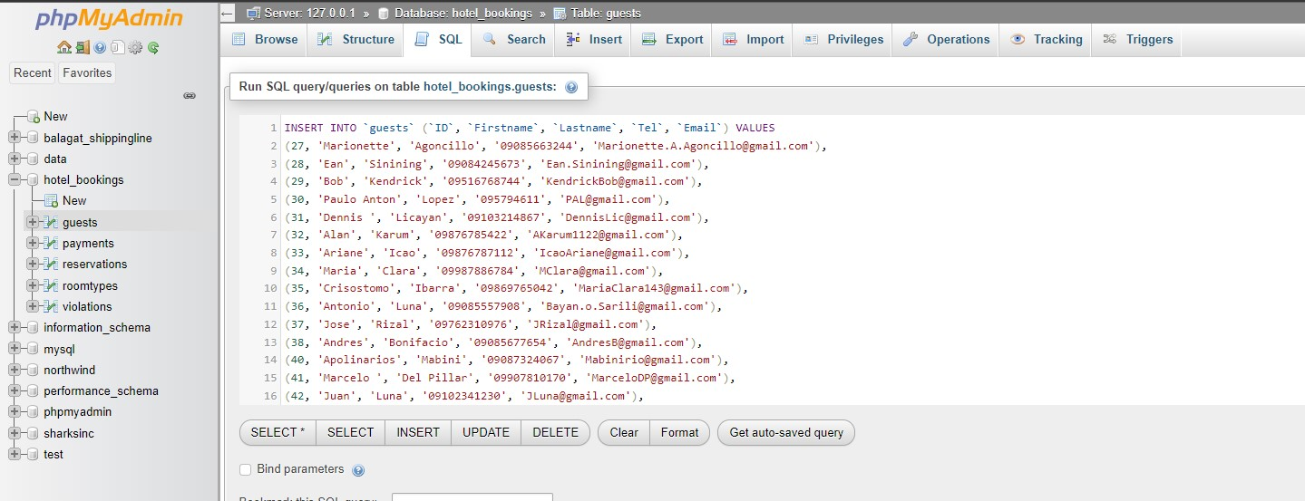

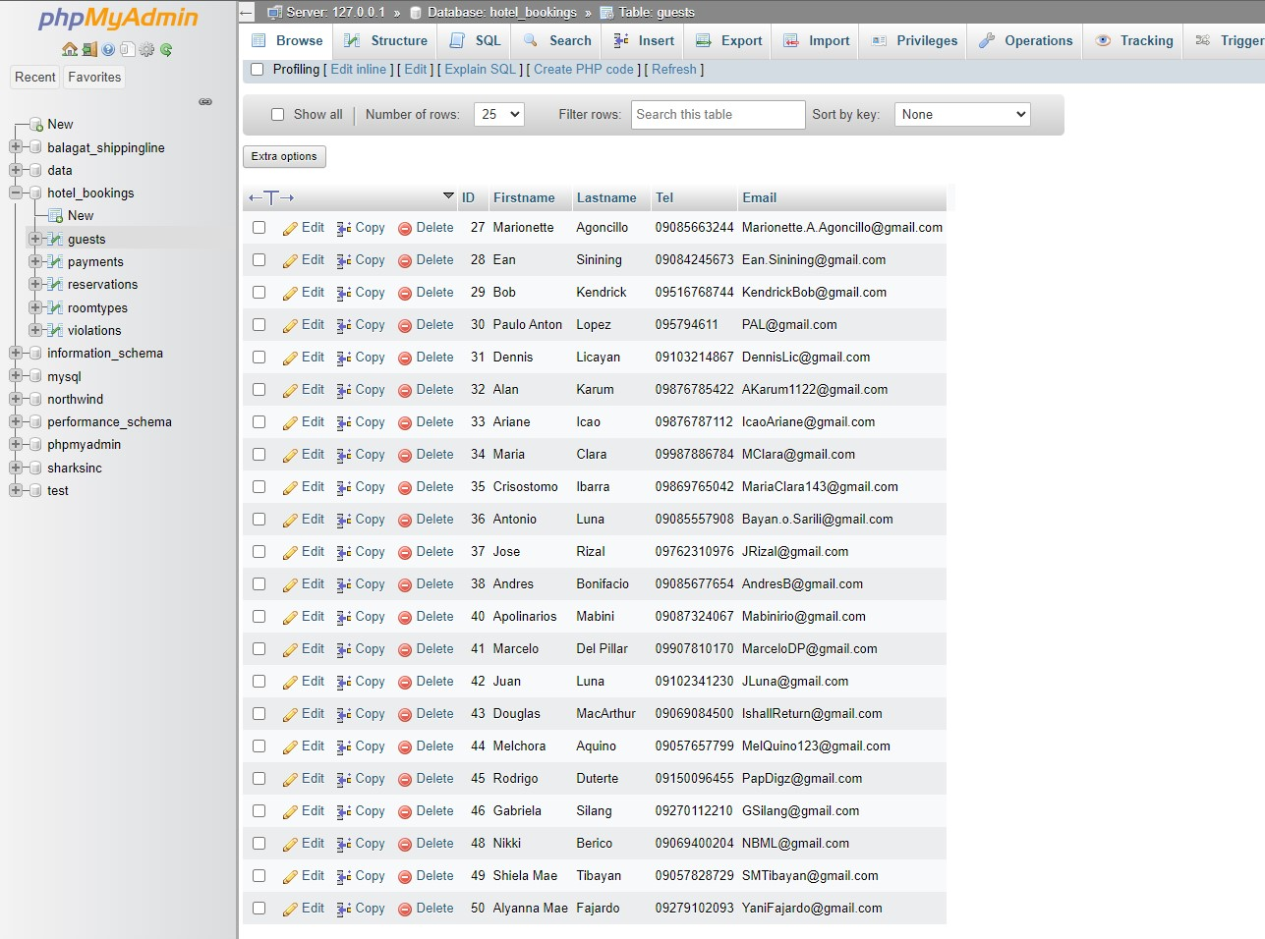

1. **Payments**

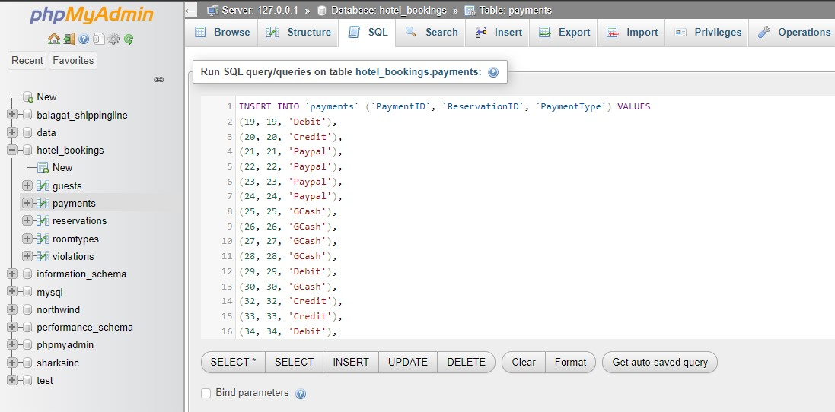

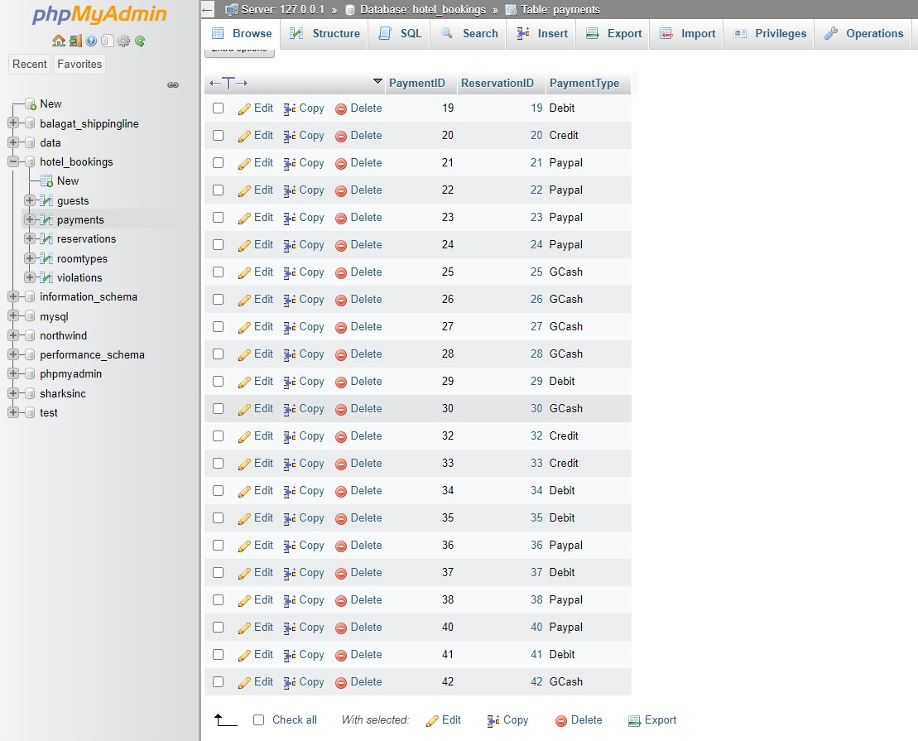

1. **Reservation**

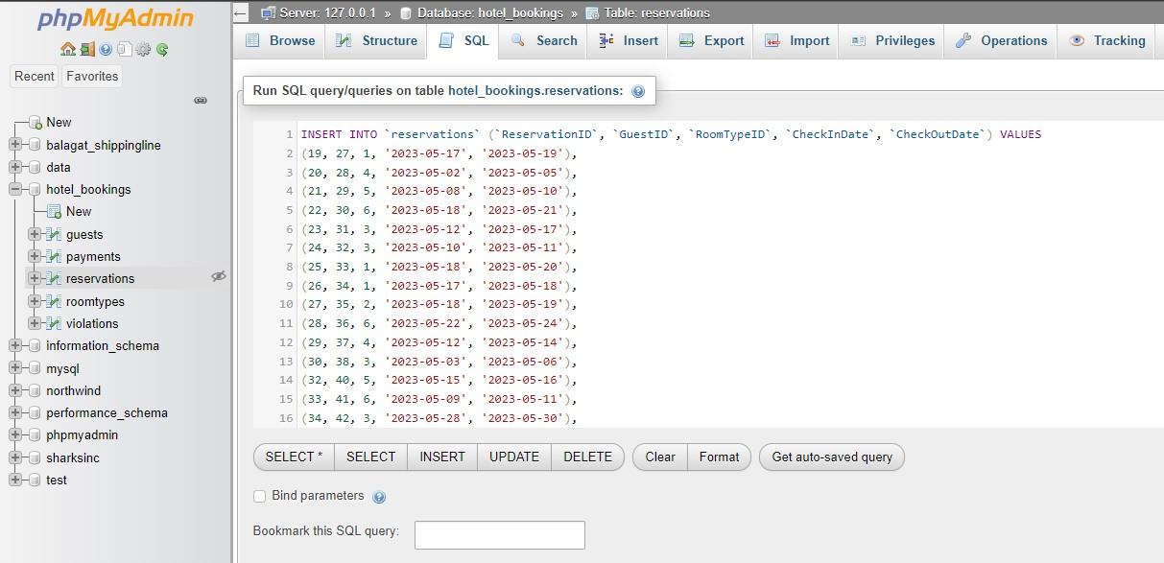

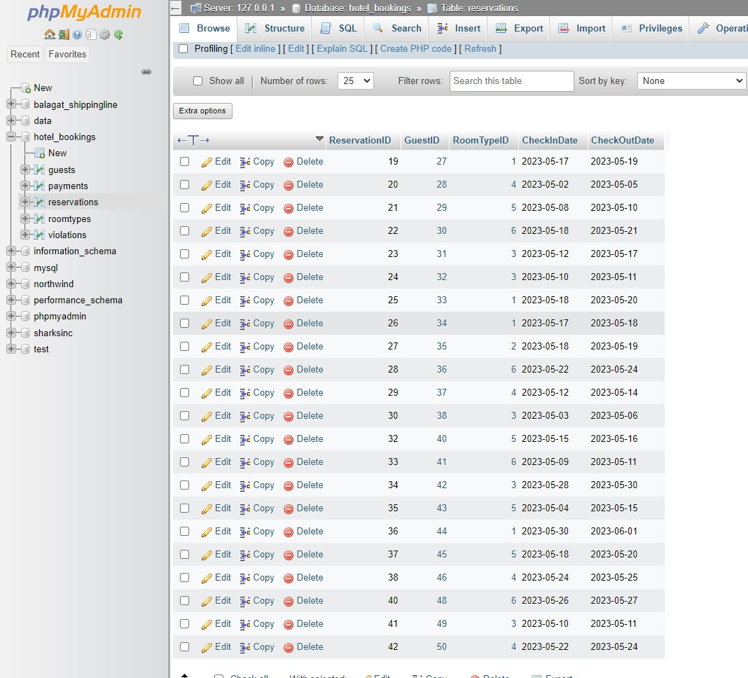

1. **Room types**

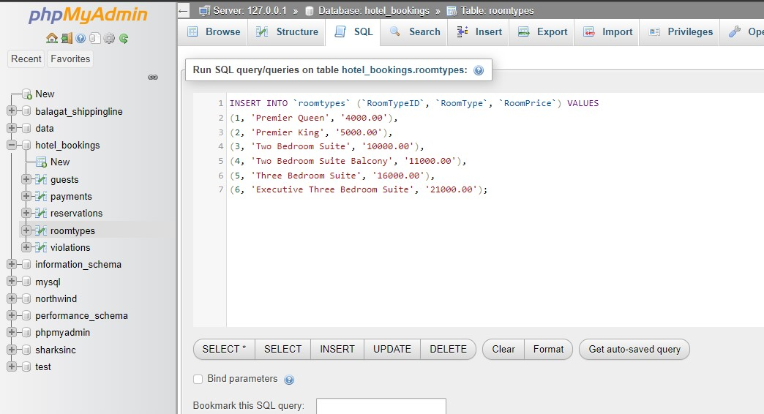

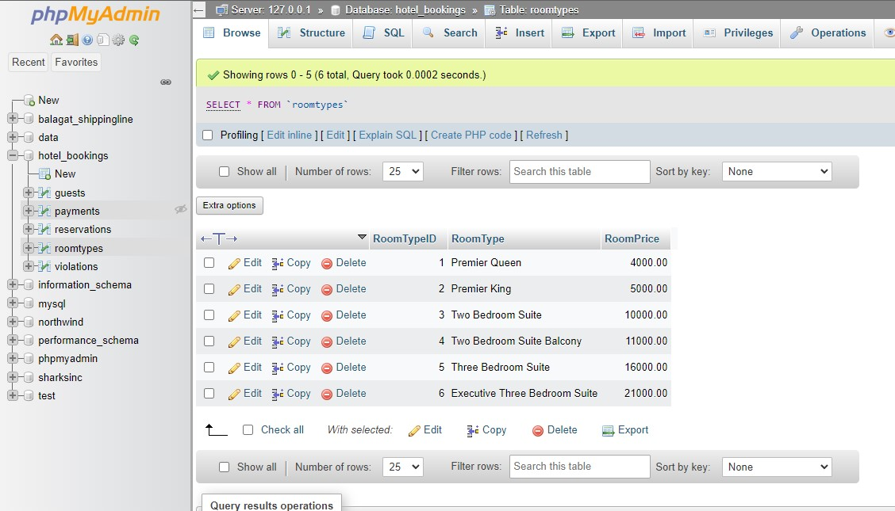

1. **violations**

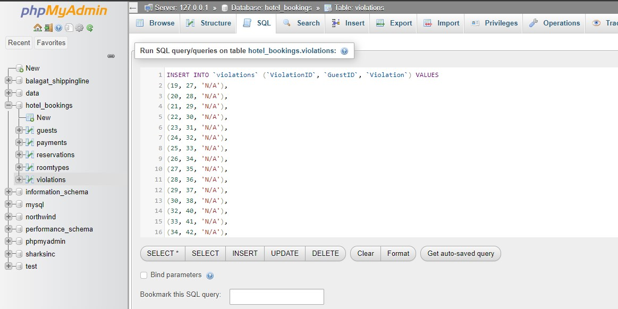

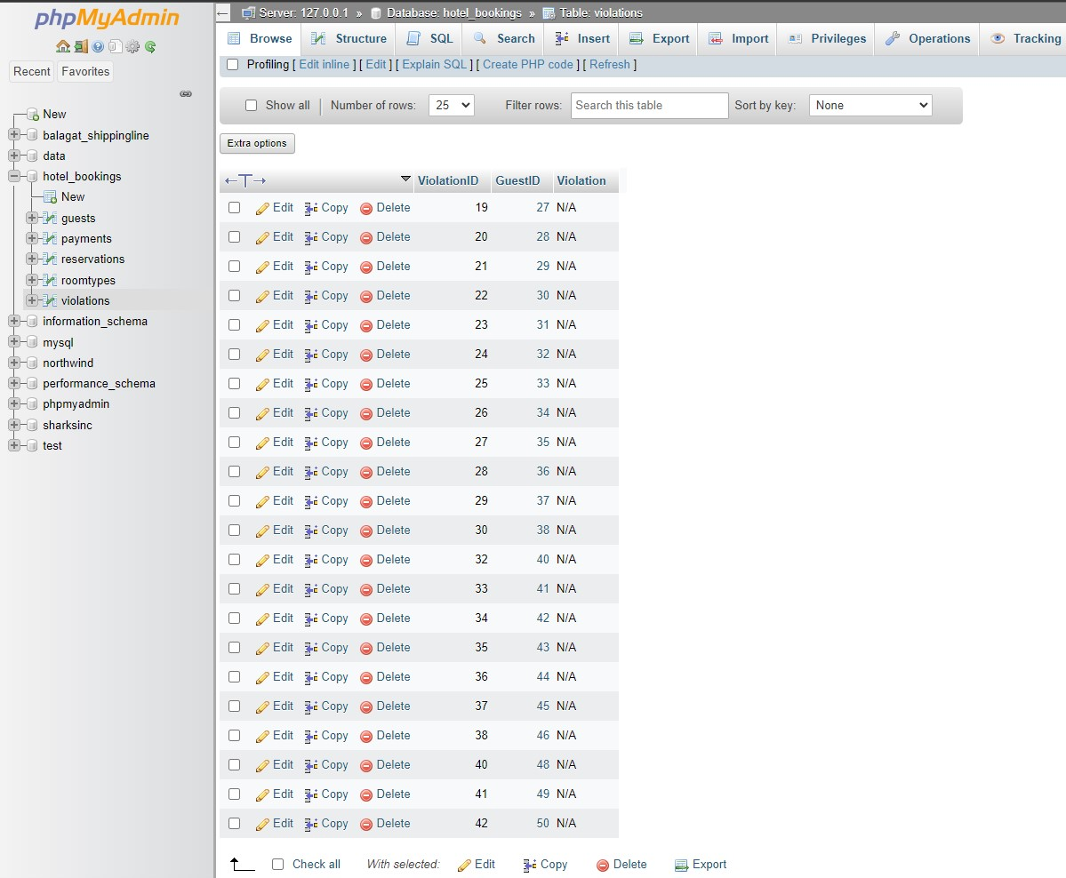

**Inner join**

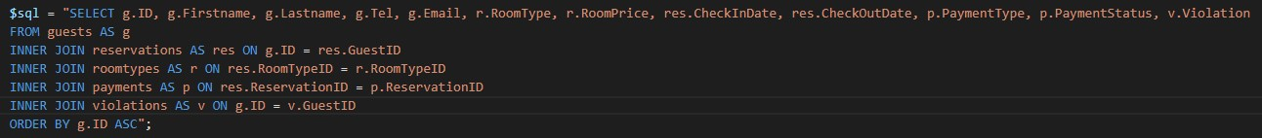

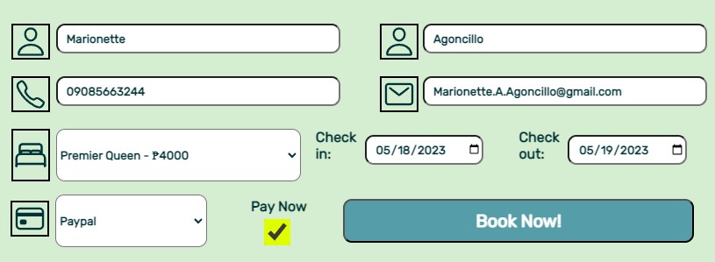



**The Prototype:**

**1.)**

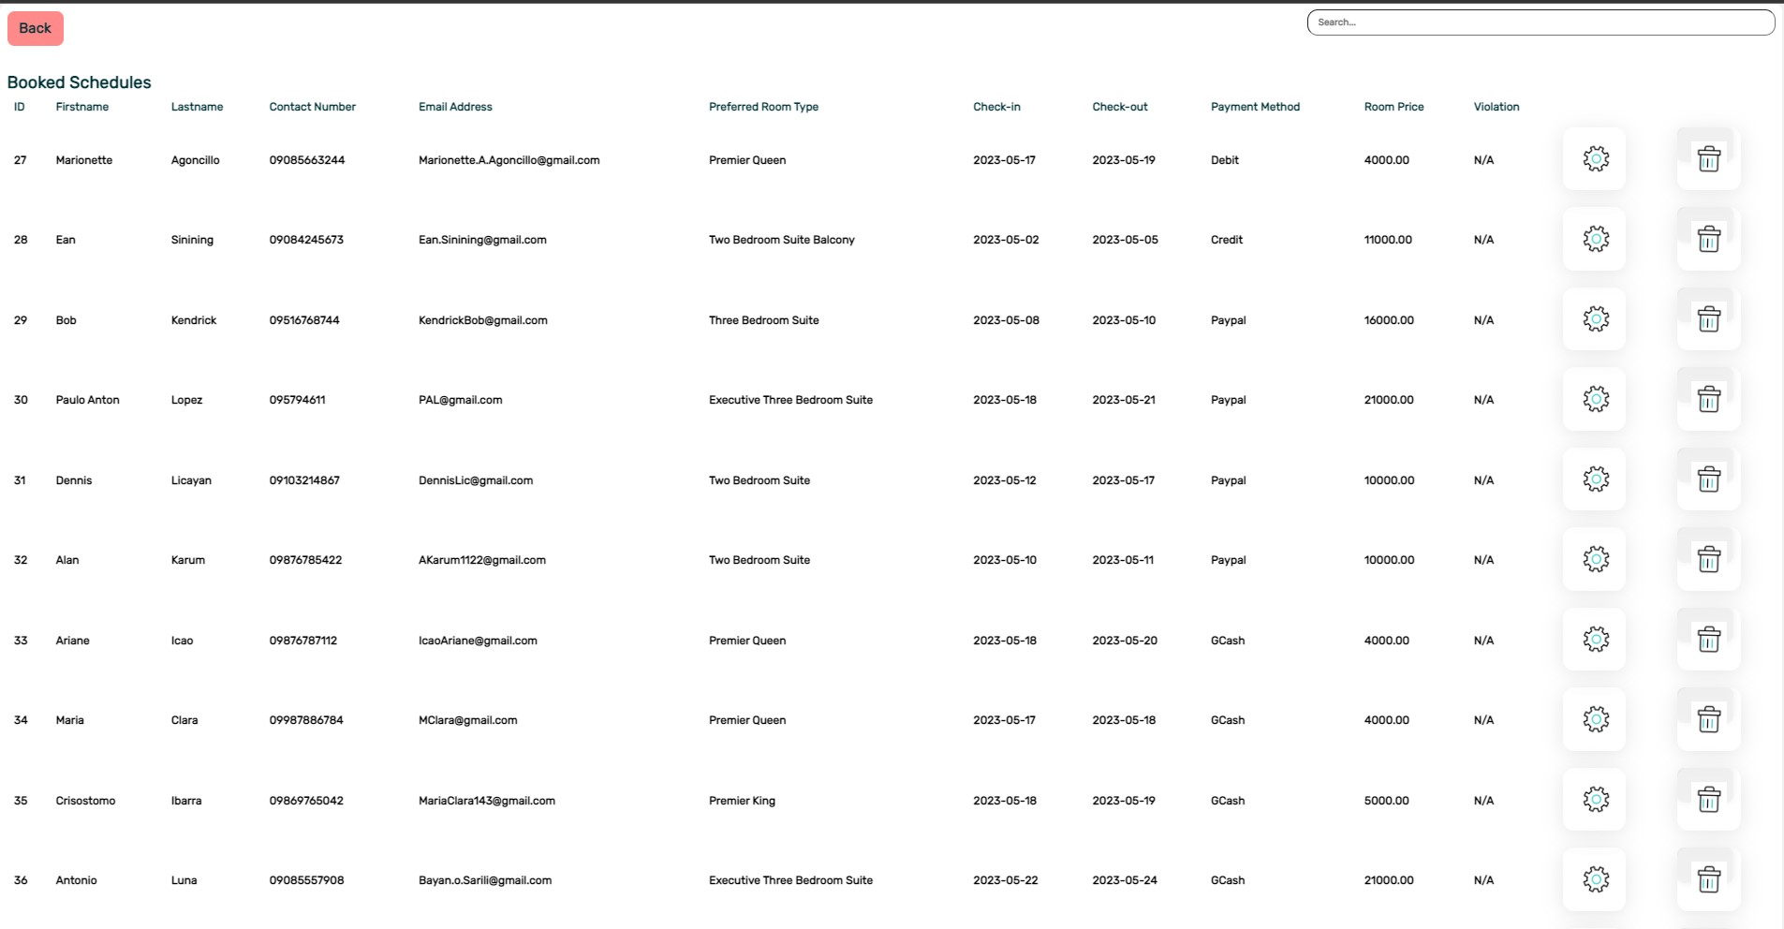

**2.)**

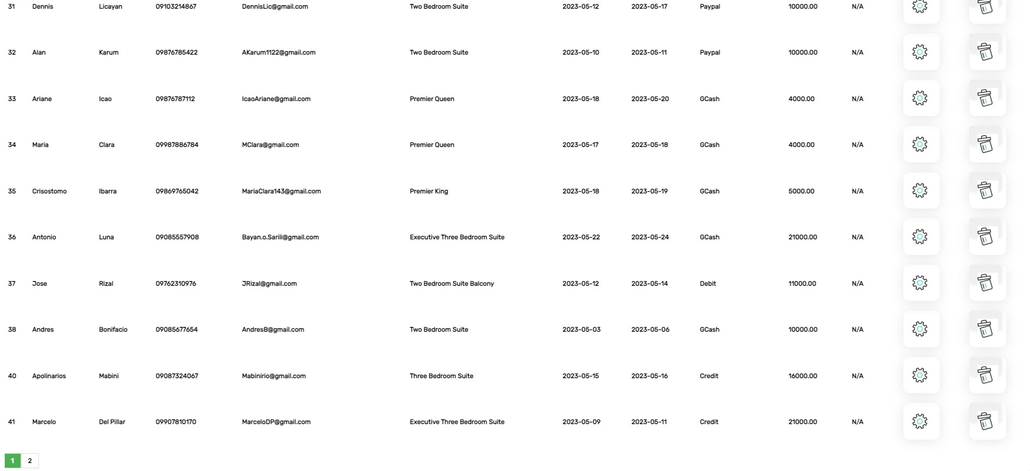

**3.)**

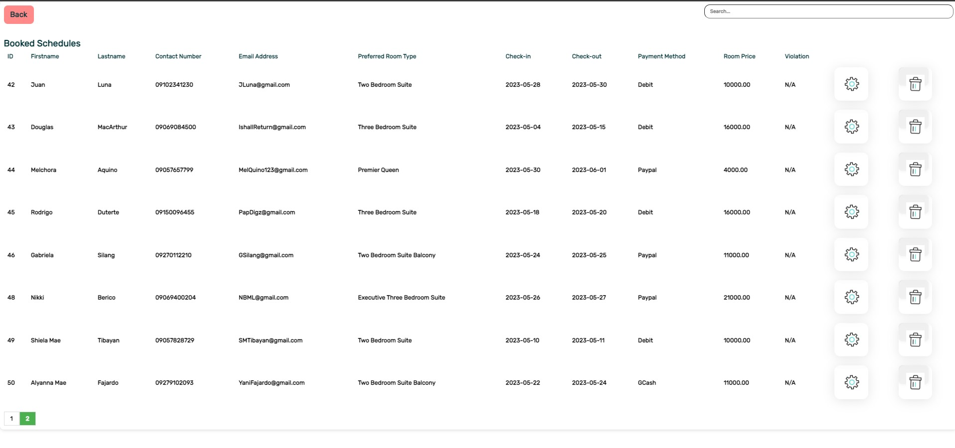

**References:   
Soutron, (2022), Business Rules in Database, https://www.soutron.com/business-rules-databasedesign/   
Gene H Fang, (2020), Normalization of Database Schema: 1st, 2nd, and 3rd Normal Forms, https://rb.gy/4qy9t**

**Submitted by: Geryson Doromal, James Paul Balagat   
Submitted to: Prof. Jenny Espader**